

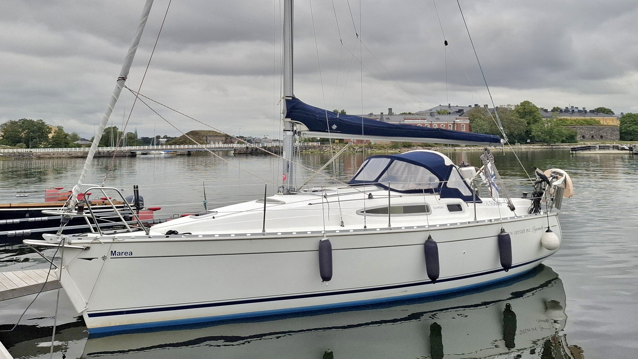

Jeanneau Sun Odyssey 29.2 (2004)
The Sun Odyssey 29.2 is a timeless and easy-to-handle family sailboat that combines solid sailing performance with a comfortable level of equipment. The boat is equipped with furling sails, an autopilot, and clear navigation electronics, making sailing effortless even with a smaller crew.
The spacious cockpit, practical deck layout, and cozy interior—featuring hot water and a refrigerator—provide comfortable conditions for both day trips and longer voyages. This Legend model comes well-equipped for enjoyable and carefree boating.
Location:
Espoo, Finland
Engine:
Yanmarin 2GM20F
18 hp

Measurements:
Length: 8.80m
Beam: 2.98m
Draft: 1.4m
Displacement: 2750kg

Tank Capacities:
Water tank 100l
Diesel tank 45l
Septic tank 50l
Sailing & Rigging
• Classic mast + mainsail (lazy bag & lazy jacks)
• Furling mast + furling genoa
• 2 x self-tailing winches (32.2)
• Halyard bags
• Mainsail, Elvström Sails, 2004, good condition, regularly serviced
• Furling genoa, Elvström Sails, 2004, good condition, regularly serviced
• Gennaker, Meripurje, 2010, like new, hardly used

Navigation & Electronics
• Raymarine ST60 Tridata (speed, depth, log)
• GPS chartplotter (color display) + Navionics Gold charts
• Autopilot (Autohelm 4000, wheel-mounted)
• Wind instrument + anemometer
• Compass (bulkhead-mounted)
• Windex
Electrical & Systems
• 12V system + 12A battery charger
• 2nd battery (service) + charging relay
• Shore power connection
• 220V outlet
Comfort & Interior
• 12V refrigerator
• Hot water boiler (15L / 220V)
• Electric shower pump
• Tableware (for 2–6 persons)
• Multiple interior options (e.g. Blue Paradiso, Royal Blue Baltic)
Deck & Cockpit
• Large sprayhood (blue)
• Cockpit cushions
• Cockpit shower (cold water)
• Removable cockpit table
• Leather-covered steering wheel
• Teak finish in cockpit (seats / floor)
Anchoring & Mooring
• Anchoring package
• Mooring lines
Additional Equipment
• CD player + FM radio + speakers
• Outboard engine bracket
• Opening gate from cockpit to stern
• Additional hatches and windows in saloon
Sanitary
• Toilet + holding tank (45L)
• 3-way valve
Other Equipment:
- Navigation lights
- Mooring lines

Blue Ocean Oy Ab reserves the right to changes in this specification list.

Yacht Broker contact:


Miku Santavirta
Yacht Broker
BlueOcean Oy
+358400443343
miku.santavirta@blueocean.fi
www.blueocean.fi

